**Development of a Mobile Game utilising Stimuli to Improve Human Reaction Time**

A Project Proposal for the Individual Project

Jake Walder

BSc Games Programming

|  |  |
| --- | --- |
| **Contents** |  |
| Abstract | 3 |
| Introduction | 3 |
| Aims | 5 |
| Objectives | 5 |
| Methodology | 6 |
| Plan | 7 |
| References | 8 |
|  |  |

|  |
| --- |
| Abstract |

The human reaction is fundamental to any everyday activity, and the speed of this reaction can often change the severity of the consequence. This project will design and implement three small games within a mobile application developed using Unity’s game engine, and will aim to improve the player’s reaction time. The games will utilise visual, auditory and tactile stimuli to induce a reaction from the user, which will then be recorded. The games will be tested by users over a set period of time, and the data will be recorded to evaluate how well the games can improve the human response time.

|  |
| --- |
| Introduction |

A human response can alter the severity of any everyday situation, so it is important to keep the time of these responses as low as possible. Whether driving or playing a sport, the outcome of every reaction will be defined by both its speed and accuracy.

It has been said that playing action video games *‘significantly reduces reaction times’* (Dye, Green and Bavelier, 2009). In order to prove this, participants played action games such as Call of Duty 2 (2005) and Unreal Tournament (1999), and their response times were tested after a period of use. These discoveries led to the motivation behind this project which is to create a series of small games. These will require the player to react quickly, improving the speed of their responses over time. The games will be simple versions of popular action game types (i.e. driving and shooting) that demand fast and accurate responses. Action games are the optimal game type for improving response times due to their nature of fast paced gameplay, and requisite for quick decisions and actions by the player. Once the player has finished a game session, a response time reading will be output and then compared to any previous plays. This should show an increase in response time from the first play session of the game when compared to the last, which will then provide proof of video games’ ability to improve response times and accuracy.

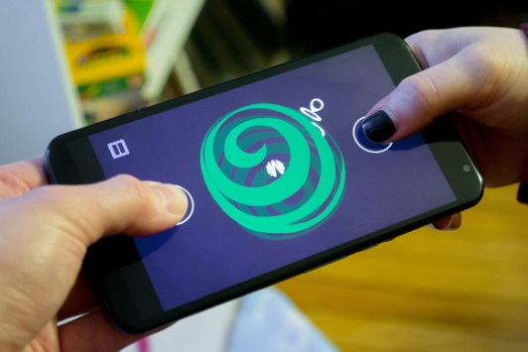There are various types of stimuli that cause reactions within games. Technology has the capability of using visual, auditory and tactile stimuli to produce a reaction from the user. Mobile phones are a great example of a device that can utilise all three (See Fig. 1 for an example of a mobile game), for instance notifications on a mobile phone can be reported in the form of visual information, auditory sounds and tactile vibrations to the user. This means that this platform is great to create a response testing game upon, as the game will be able to produce the three stimuli to the user, all within one device in the same instance. A study showed that the response to *‘tactile stimuli was significantly shorter’* (Ng and Chan, 2012), followed by auditory and then visual stimuli respectively. This project will test the concept of varying response times to each stimulus by utilising each stimulus at different times. The game will always need to consist of visual stimuli, but it will be enhanced by auditory and tactile stimuli and then compared to one another.

Figure 1: A simple mobile phone game (Greenbot, 2015)

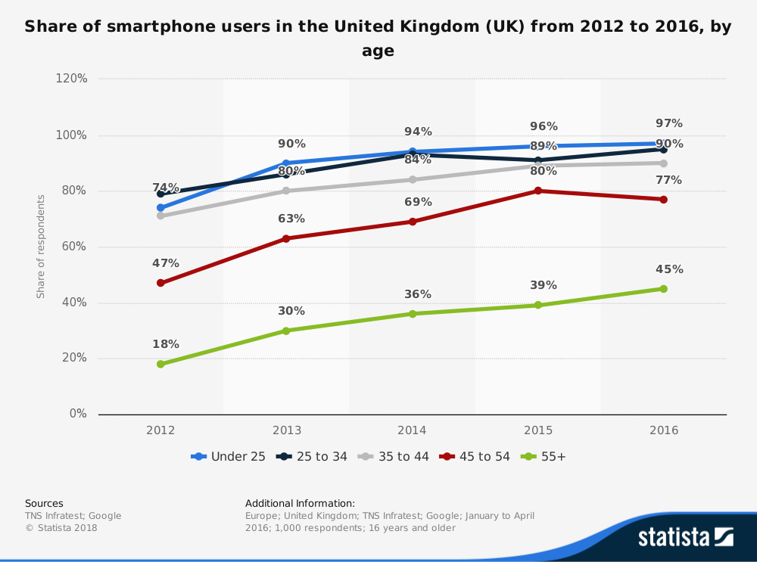Not only are mobile phones a great platform for these simple games, but they are also ideal for making these games very accessible to the public. There is a huge increase in the number of smartphones per capita; the population of smartphone users was at a rate of 75% of males and 73% of females in the UK in 2016, which means that the population of users increased by 21% and 25% respectively since 2012. (Statista, 2018). Fig. 2 below also shows the main age demographics of smartphone users and the growth of each group.

Figure 2: The percentage of smartphone users in the UK (Statista, 2018)

These games will be simple and accessible, yet retaining a challenging and entertaining factor, making the improvement of one’s reaction time enjoyable. This means that this project will enable both gamers and non-gamers to improve their response time for any reason they deem necessary, whether it’s to improve their ability in sports, driving, or video games.

|  |
| --- |
| Aims |

* The primary aim is to create a mobile application for Android using Unity, consisting of three games that test response time.
* The secondary aim is to test multiple users’ response times over a set period, and compare the results to show any improvement of their response time.

|  |
| --- |
| Objectives |

Essential Objectives:

* Create a clear and easy to navigate User Interface (UI) to store the 3 games that will be made.
* Create the three games which are as follows:
  + A shooting game where random targets will appear on screen that the player must shoot.
  + A driving game where a random course will be created, and the player must choose the correct direction when prompted.
  + A dodging game where missiles will appear on screen that the user must dodge before being hit.
* Introduce the addition of auditory and tactile stimuli to initiate reactions.
* Design two scoring algorithms:
  + A score which combines the players’ reaction time and accuracy to output an integer style score.
  + A score that shows the average reaction time of the player which can be used for testing purposes.
* Test a group of users’ reaction times over a set period of play-time to assess the base state, and then determine any improvement of reaction time through extended participation, by comparing visual stimuli to reactions caused with the addition of auditory and tactile stimuli.

Surplus Objectives:

* Create a leaderboard for users to compare their reaction times against others.
* Design levels and waves for the games instead of random generation to allow users to make progression through the game.
* Create different environment styles for each game.

|  |
| --- |
| Methodology |

The project will begin with a literary review that will discuss any previous work relative to the human response time, and also video games’ impact on the speed and accuracy of human reaction. The processes taken to calculate response time will be considered, as well as the procedures other studies have taken to try and improve the responses over a period of testing.

Once the literary review has taken place, the design and development of the application will begin. The goal for this project is to consider any previous work/games, and then refine and improve upon them during the planning process. The design will begin with a simple overview of the application outline and also the three games. The games will need to be designed bearing in mind how the response time calculator will work; this will differ between the three games. Due to this differentiating factor, the response times will not be able to be compared to one another, and will leave the user with three separate response time averages when the games are played; this will be considered when it comes to testing. The games’ visual design will be simple to accommodate for mobile phones’ smaller screens, relative to the size of a computer monitor. The UI for the games will also be clear and basic to reduce as much confusion for the user (which will also be minimised by a user guide that will be included within the app). During the application’s development, benchmarking will be done using multiple Android devices. This will be able to test how the application performs on lower end specifications, as well as how different resolutions will affect the application’s UI. The assets that will be used for the game will come from a simple asset modelling website called Kenney (2018). The budget will need to be £25 in order to access all the assets required from Kenney, but as Unity’s engine is free to use, that will be the only cost.

Testing will be carried out upon completion of the application. Participants will be required to use the application for a set period of time, and then their results will be taken. Three groups of participants will be used to test the difference in response times between visual stimuli on its own, visual with auditory stimuli added, and finally with visual, auditory, and tactile stimuli combined. These results will then be compared to evaluate the application’s ability to improve the user’s reaction time. The intended outcome of this project is to prove that video games do have the ability to improve reaction times, and that an easily accessible and simple game can aid that improvement.

|  |
| --- |
| Plan |



|  |
| --- |
| References |

Dye, M., Green, C. and Bavelier, D. 2009. Increasing speed of processing with action video games. *Current directions in psychological science*, 18(6), pp. 321-326.

Whitham, R. 2015. *10 multiplayer android games where you share the same phone [online].* Greenbot. Available from: <https://www.greenbot.com/article/2876235/10-android-games-you-and-a-friend-can-play-on-the-same-phone.html#slide1> [Accessed 1 November 2018].

Ng, A. and Chan, A. 2012. Finger Response Times to Visual, Auditory and Tactile Modality Stimuli. *Proceedings of the International MultiConference of Engineers and Computer Scientists*, 2.

## Statista, 2018. *Share of smartphone users in the United Kingdom (UK) from 2012 to 2016, by gender [online].* Google. Available from: <https://www.statista.com/statistics/732591/united-kingdom-smartphone-users-by-gender/> [Accessed 1 November 2018]

## Statista, 2018. ***Share of smartphone users in the United Kingdom (UK) from 2012 to 2016, by age [online].* Google. Available from:** <https://www.statista.com/statistics/732535/united-kingdom-smartphone-users-by-age/> **[Accessed 1 November 2018]**

Kenney, 2018. *Kenney Bundle [online].* Itch Corp. Available from: <https://itch.io/s/6789/kenney-bundle> [Accessed 1 November 2018]